

**Tribhuvan University**

**Faculties of Humanities and Social Sciences**

**MUSIC STREAMING PLATFORM**

**A PROJECT PROPOSAL**

**Submitted to**

**Department of Computer Application**

**Ratna Rajyalaxmi College**

**Exhibition Road, Kathmandu**

***In partial fulfillment of the requirements for the Bachelors in Computer Application***

**Submitted by**

Bisham Raj Pandey

Bishal Regmi

February, 2025

**TABLE OF CONTENTS**

1. INTRODUCTION 1

2. PROBLEM STATEMENT 2

3.OBJECTIVES 3

4.METHODOLOGY 4

4.1. Requirement Identification 4

4.1.1. Study of Existing System 4

4.1.2. Requirement Collection 5

4.2. Feasibility Study 6

4.2.1 Technical Feasibility 6

4.2.2. Operational Feasibility 7

4.2.3. Economic Feasibility 7

4.3 High Level System Design 8

4.3.1. System Flowchart 8

4.4 Description of Algorithm 9

5.GANTT CHART 10

6.EXPECTED OUTCOME 11

7.REFERENCES 12

**TABLE OF FIGURES**

Figure 1: System Flowchart of Music Streaming Platform 8

Figure 2: Gantt Chart of Music Streaming Platform 10

# 1. INTRODUCTION

A music streaming platform is a system where users can listen to and discover new music. It allows users to explore a variety of songs and express their preferences through a simple interaction model. Artists will have the opportunity to showcase their work, while users can engage with the music by liking songs and curating their own playlists.

The music streaming platform aims to redefine user experience and address common challenges in modern music discovery. This system will provide a seamless and intuitive interface where users can listen to songs, like them, and build personalized playlists. Artists will have the ability to upload their tracks and highlight key segments for users to preview, allowing listeners to experience the best parts of a song before deciding whether to like it. The platform will introduce a recommendation algorithm that analyzes user preferences, such as liked songs, genres, and listening patterns, to suggest music tailored to each individual. The interactive swipe-based design enhances engagement by making the process of discovering new music effortless and enjoyable. Additionally, users will be able to revisit their liked songs, organize them into playlists, and explore more music from their favorite artists, creating a highly personalized listening experience.

The main goal is to create an engaging and personalized music discovery experience. This software will allow users to interact with music in a more intuitive way while helping artists connect with their audience. I propose an online music streaming platform that adapts to user preferences and enhances music discovery through a dynamic recommendation system.

# 2. PROBLEM STATEMENT

Modern music streaming services face several challenges that impact both artists and listeners. One significant issue is the disparity in revenue distribution, where major record labels capture nearly 85% of all U.S. digital music royalties, leaving independent artists with minimal earnings . This imbalance often forces artists to conform to industry expectations, compromising their creative vision [1].

Additionally, the prevalence of algorithm-driven recommendations can limit music discovery, as these systems tend to favor mainstream tracks, making it difficult for emerging artists to gain visibility. This focus on popular content can lead to a homogenized listening experience, reducing the diversity of music explored by users.

From the listener's perspective, the unavailability of certain songs across platforms poses a significant inconvenience, as licensing restrictions prevent access to a comprehensive music library. Moreover, the lack of seamless communication features between artists and fans hampers community building and direct feedback.

Furthermore, the shortening attention spans of younger audiences have influenced music consumption patterns. Studies indicate that the average consumer attention span has decreased to approximately 8 seconds. This shift has led to a trend where artists create shorter songs with catchy, attention-grabbing segments designed for virality on platforms like TikTok . While this approach can boost an artist's visibility, it may also discourage the production of longer, more complex compositions, potentially limiting the diversity and depth of musical content available to listeners.

These challenges highlight the need for a more equitable and user-centric music streaming platform that supports artist creativity, enhances music discovery, and fosters a vibrant community.

# 3.OBJECTIVES

The main objective of this project is to develop a music streaming platform that provides users with a seamless and engaging way to discover and interact with music while giving artists a space to showcase their work. The objective of this system is:

* To develop a web-based, responsive music streaming platform that allows users to listen to, like, and curate playlists of their favorite songs.
* To implement a structured system for managing songs, artists, user interactions, and recommendations based on listening preferences.
* To integrate a dynamic recommendation algorithm that personalizes music suggestions using user statistics such as like history, genre preferences, BPM, and artist affinity.

# 4.METHODOLOGY

## 4.1. Requirement Identification

Secondary Sources of data collection was the primary method to gather requirements for the project. This has led to us finding useful requirements for the system.

### 4.1.1. Study of Existing System

Existing music streaming platforms face several challenges that impact both artists and listeners [2]. One significant issue is the disparity in revenue distribution, where major record labels capture a substantial portion of digital music royalties, leaving independent artists with minimal earnings. This imbalance often forces artists to conform to industry expectations, compromising their creative vision. Additionally, the prevalence of algorithm-driven recommendations can limit music discovery, as these systems tend to favor mainstream tracks, making it difficult for emerging artists to gain visibility [3]. From the listener's perspective, the unavailability of certain songs across platforms poses a significant inconvenience, as licensing restrictions prevent access to a comprehensive music library. Moreover, the lack of seamless communication features between artists and fans hampers community building and direct feedback.

Furthermore, the shortening attention spans of younger audiences have influenced music consumption patterns. Studies indicate that the average consumer attention span has decreased to approximately 8 seconds [3]. This shift has led to a trend where artists create shorter songs with catchy, attention-grabbing segments designed for virality on platforms like TikTok. While this approach can boost an artist's visibility, it may also discourage the production of longer, more complex compositions, potentially limiting the diversity and depth of musical content available to listeners.

**Problems of Existing System**

* **Limited Music Discovery:** Algorithm-driven recommendations often prioritize mainstream music, making it challenging for new or niche artists to reach audiences.
* **Content Unavailability:** Licensing issues lead to certain songs being unavailable on various platforms, limiting listeners' access to a full range of music.
* **Reduced Attention Spans:** The trend towards shorter, viral-ready music clips caters to diminishing attention spans but may undermine the appreciation for diverse musical expressions. [1]

**Advantages of Proposed System**

To overcome the restrictions of the above system, Music streaming platform is proposed which has the following advantages:

* **Enhanced User Engagement:** The swipe-based interface, provides an interactive and intuitive way for users to discover and engage with music.
* **Personalized Recommendations:** Utilizing user statistics such as like history, genre preferences, and listening habits, the system offers tailored music suggestions that adapt in real-time.
* **Admin Oversight:** The admins will help to make the platform clean and safe

### 4.1.2. Requirement Collection

To initiate the development of the proposed system, we embarked on a comprehensive requirement analysis phase, drawing insights from existing music streaming platforms. This process involved meticulous data collection to ensure a thorough understanding of the project's scope. Subsequently, we proceeded with the system's implementation, collaboratively selecting a theme for the application based on our collective ideas. The development phase commenced, and the system was successfully completed. The project began with the establishment of clear objectives, leading to the initiation of the requirement collection process. Various methods were employed for requirement collection:

* **Literary Analysis**

Through an extensive review and critical analysis of existing literature, we identified previous works, highlighting their strengths and weaknesses. This process informed the project's aims and objectives by revealing the shortcomings of prior solutions. The literature review played a crucial role in refining the project's direction, guiding it toward addressing issues identified in past research.

* **Observation**

We examined multiple music streaming platforms to identify current trends in music delivery and streaming culture. Simultaneously, we conducted a review of typical music streaming systems to gain insights into the music delivery process. This analysis aimed to inform a comprehensive understanding of music streaming platforms, shaping a well-informed approach to application development.

* **Brainstorming**

We utilized brainstorming sessions as a creative tool for idea generation. The requirements for the system were partially derived from this process, capturing a range of ideas and insights.

## 4.2. Feasibility Study

The analysis of feasibility has concluded that the project is feasible with respect to time and cost. The technology used to develop are almost Open Source, therefore less cost for implementation and maintenance will be involved.

### ****4.2.1 Technical Feasibility****

The proposed music streaming platform is technically feasible, utilizing the MERN stack (MongoDB, Express.js, React.js, Node.js) for a seamless full-stack environment. MongoDB efficiently manages music data, while Node.js enables real-time recommendation updates and playback. The system is scalable. Performance challenges, such as smooth music transitions and optimized database queries, will be addressed through efficient backend logic. Overall, the chosen technologies ensure reliability, scalability, and a smooth user experience.

* Language used: MongoDB, Express.js, React.js, Node.js

### 4.2.2. Operational ****Feasibility****

Operational feasibility refers to how well the system addresses the problems it was designed to solve and takes advantage of opportunities identified in the system's scope. The project is considered feasible from an operational standpoint.

* The existing operational model ensures efficient throughput and quick response times.
* The organization will reap significant benefits from the proposed system.
* The available resources are utilized effectively to deliver a high-quality system within the set timeline.

### 4.2.3. Economic ****Feasibility****

This section evaluates the economic benefits the proposed system will bring to the organization.

* The system offers cost-effectiveness.
* The streamlined resource management will lower the overall system cost.
* The advantages provided by the system will significantly outweigh its costs.

## 4.3 High Level System Design

### 4.3.1. System Flowchart

The system flowchart of music streaming platform is shown as follows:

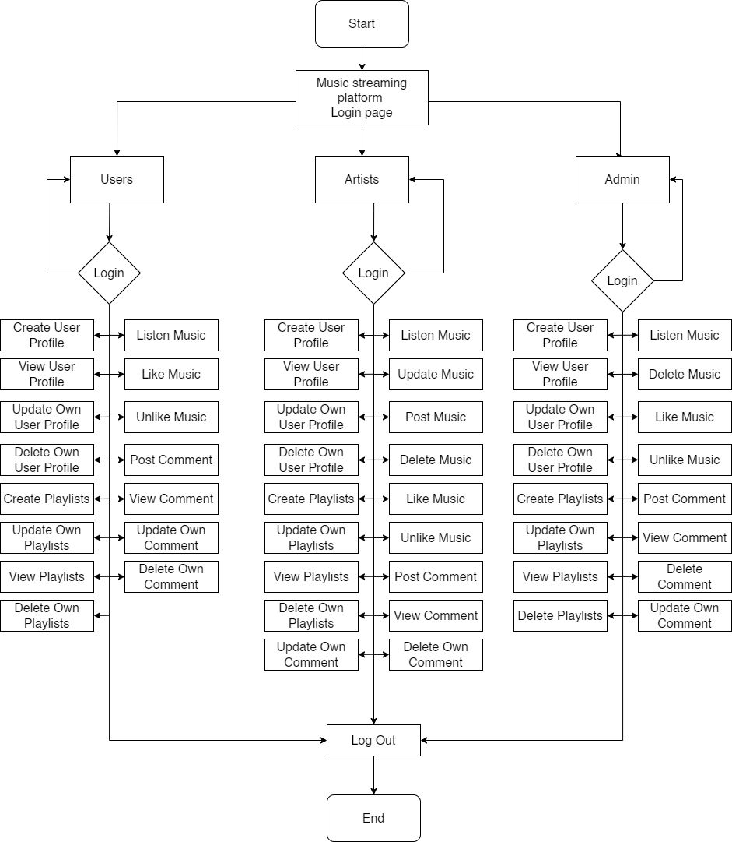

# Figure 1: System Flowchart of Music Streaming Platform

## 4.4 Description of Algorithm

Collaborative filtering is a recommendation technique that predicts a user’s preferences based on the behavior of similar users. Instead of analyzing song attributes, it focuses on user interactions, making recommendations more personalized and dynamic.

Working of Collaborative Filtering:

* **Data Collection –** Gathers user interactions (likes, skips, listening duration) to build a preference database.
* **User-Item Matrix Creation –** Constructs a matrix mapping user to songs based on their interactions.
* **Similarity Calculation –** Identifies users with similar listening behaviors using similarity metrics like cosine similarity.
* **Recommendation Generation –** Suggests songs a user hasn’t heard based on what similar users enjoy.
* **Continuous Improvement –** Updates recommendations in real-time as users interact with new songs.

# 5.GANTT CHART

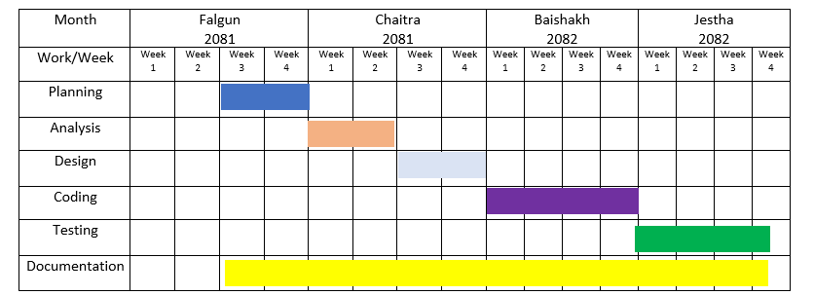

# Figure 2: Gantt Chart of Music Streaming Platform

The project is set to begin in the third week of Falgun 2081 with the Planning phase, which will last for one week, establishing a structured approach for the development process. Analysis will follow, spanning from the fourth week of Falgun to the first week of Chaitra 2081, where system requirements will be identified and documented.

Next, the Design phase will take place from the second to the fourth week of Chaitra 2081. During this stage, the system’s structure, user interface, and database design will be formulated to ensure smooth development. Coding will commence in the first week of Baishakh 2082 and continue until the fourth week, focusing on translating the design into a functional system.

Once development is complete, Testing will begin in the second week of Jestha 2082, ensuring the system operates effectively and meets the desired objectives. Documentation will be an ongoing process, starting in the third week of Falgun 2081 and continuing through the end of Jestha 2082, ensuring detailed records are maintained throughout the project.

By the end of Jestha 2082, the project is expected to be fully implemented, tested, and documented, ready for deployment or further refinement.

# 6.EXPECTED OUTCOME

After the completion of the project, we expect the subsequent outputs which can minimize the issues likewise as solve the prevailing problem.

* Improved User Experience: Users will be able to effortlessly interact with the platform, swiping through songs, and enjoying the content with minimal effort.
* Responsive Interface: The platform will adapt seamlessly to various devices, ensuring smooth performance across all screen sizes.
* Effective Communication: Users and artists can engage with each other through features like direct messaging and comments, fostering better interaction.

# 7.REFERENCES

# Bibliography

|  |  |
| --- | --- |
| [1] | J. Daher, 18 11 2023. [Online]. Available: https://www.thedartmouth.com/article/2023/09/trends-shorter-songs. [Accessed 25 2 2025]. |
| [2] | S. Bludov, "www.dataart.com," 12 2019. [Online]. Available: https://www.dataart.com/media/3234/shortening-attenting-spans-sb.pdf. [Accessed 23 2 2025]. |
| [3] | S. Stella, "publicknowledge.org," 9 3 2023. [Online]. Available: https://publicknowledge.org/new-public-knowledge-paper-shines-a-light-on-the-broken-music-streaming-industry. [Accessed 9 3 2023]. |
| [4] | J. Shotwell, "https://artists.bandsintown.com/," [Online]. Available: https://artists.bandsintown.com/support/blog/short-attention-spans-are-dramatically-altering-songwriting-heres-how. [Accessed 25 2 2025]. |
| [5] | "www.sharetopros.com/," 16 8 2023. [Online]. Available: https://www.sharetopros.com/blog/the-challenges-and-obstacles-facing-the-music-industry-today.php. [Accessed 25 2 2025]. |